Cementing The Gains of Project Exceed

Through a school improvement grant from Lilly Endowment, Inc. and supporting archdiocesan benefactors, the Archdiocese of Indianapolis implemented Project EXCEED, a comprehensive, measurable, and sustainable initiative that has raised the bar for academic achievement for all 23,000 archdiocesan students, including 12,000 students in Indianapolis/Marion County. The project’s three over-arching goals are to:

- Recruit, retain, develop, and reward the best teachers and administrators;
- Raise the level of students’ performance and report their progress; and
- Reach out to those students with special needs—those who have advanced capabilities, who struggle with traditional modes of teaching and learning, who use English as a second language, or who fight to overcome the challenges of poverty.
Summary of Goal One: Recruit, retain, develop, and reward the best teachers and administrators
- Developed strategies for educators based on the four main principles of the Teacher Advancement Program (Tap)
- Trained school staffs and implemented Tap principles in 13 schools
- More than 5,000 staff members participated in over 350 professional development activities
- Established a 52-hour Teacher Mentor Certification Program consistent with state standards
- Performance-based pay supported by 83% of staff from Tap payout schools
- Payouts valued at more than $380,000 to 334 teachers
- Teacher payouts range between $400 and $2,900
The implementation from 2001-2006 has included the studying of best practices, identifying needs, developing school improvement plans, surveying stakeholders, establishing key relationships with higher education institutions, hiring a team of specialists to address each goal and objective, and training teachers and administrators.

Project EXCEED’s success stems from the interrelated nature of the innovative programs and approaches. Project Exceed has led to systemic change in how educators reach students, how student and school progress is reported and how the archdiocese responds to results in central and southern Indiana’s Catholic schools.

Over the past six years Project Exceed has been instrumental in developing and implementing the school improvement efforts which have resulted in documented and significant gains in student achievement. Now, the archdiocese prepares for replication of the efforts in all of its schools to sustain and strengthen the momentum of success. This is a summary of the Project and a strategy for moving forward.

A New Era of Standards, Assessment and
Accountability in Catholic Education

Catholic schools have always been committed to providing strong academic environments, which enable students to grow to their full potential. But, with a growing number of choices for parents and students, it has become even more important to demonstrate the benefits of a Catholic education.

The results of Project EXCEED have been astonishing; students, administrators and educators at Catholic schools have demonstrated measurable levels of excellence, achievement, growth and proficiency. The rich environment in these schools focused on faith, academic rigor, good citizenship, social justice, technology and community provides students with the opportunity to realize greater academic growth than their counterparts in other schools. Further, high expectations from archidocesan educators, extensive training opportunties and resources to implement change at the classroom level has helped to create a community of exceptional teachers and administrators.
Summary of Goal Two: Raise the level of students’ performance and report their progress
- Implemented value-added assessment model in all 67 archdiocesan schools
- 26 schools completed audits, developed school improvement plans and enhanced data collection
- Maintained growth in ISTEP test scores – 20 % higher than state average
- Demonstrated student performance on standardized tests increased over time
- Achieved a high school graduation rate of 96 percent (state average 75.5 percent)
- 56 schools achieved accreditation by the North Central Association Advanc-ED
- Archdiocese achieved NCA Advanc-ED District Accreditation
- Total of 22 Blue Ribbon Schools in five years from US Department of Education

The next phase of Project EXCEED will focus on full implementation of best practices throughout all 67 archdiocesan schools.

Educational Standards in Indiana

Less than a decade ago, Indiana’s academic standards, requirements for a high school diploma and college-bound rates were among the worst in the country (Finn). Early results of the mandated Indiana Statewide Testing for Educational Progress (ISTEP) showed Indiana students not achieving at the level they should be. While major challenges still exist, today Indiana is one of only three states to receive the Fordham Foundation’s top grade of “A” on its state standards.

Standards are but one of three key components of school reform. The other two critical elements are accountability and testing (Finn). Success in a standards environment is directly related to the congruence between the taught, written and tested curriculum (English).
Based upon the values of the Roman Catholic Church, it is the archdiocese’s goal to guarantee Every Student Every Day⎯
Challenge and Success.

While Indiana has developed standards recognized as exceptional by national experts, those standards must be effectively implemented if they are going to add real value to the intellectual development of Hoosier children. To determine if the standards are taught in a meaningful way, students must be tested (assessed) and students and educators must be held accountable.

Educational Testing (Assessment) in Indiana

For Indiana students and educators, the high-stakes assessment tool is the Indiana Statewide Testing for Educational Progress-Plus (Istep+). All students in grades three through ten take the Istep+ test which is developed in response to the Indiana Academic Standards.

As all archdiocesan schools are accredited by the Indiana Department of Education, participation in annual Istep+ testing is required. Results demonstrate that students in archdiocesan schools constantly score measurably higher than the state average and this has risen significantly since the inception of Project EXCEED.

However, with high proficiency it is also important to monitor student growth as well. Proficiency is the ability of students to meet an expected level of academic performance based upon standards, while growth is the gain in student achievement from one year to the next. While Istep+ accurately measures proficiency in state standards, value-added assessment is needed to measure and report annual growth.

Value-Added Assessment in the Archdiocese

Through Project Exceed, proficiency and growth are now monitored at the individual student level using value-added assessment data for all archdiocesan students. The value-added assessment model was developed by William Sanders after more than twenty years of research and demonstrates more than student family life, income or ethnicity—that teachers matter the most to a student’s academic achievement. This moves accountability to the individual level for both teachers and administrators. (For a more complete discussion of value added assessment, see the article, “Teacher Impact on Student Proficiency and Growth” in this issue).
Summary of Goal Three: Reach out to students with special needs
- Achieved a 20% increase in the number of students served with special needs
- More than 669 participants attended 38 training sessions on topics related to special needs
- 222 teachers and principals participated in a Multi-sensory Reading course
- 22 schools received state-of-the-art technology, including new computer labs and classroom PCs
- Successful Latino Outreach programs in center city schools are now expanding to other schools
It is the expectation, across the archdiocese, that all schools will demonstrate both proficiency and growth with their students. In order to accomplish this goal, the teacher needs to have a clear understanding of what is expected, have timely and relevant data available for analysis and the skills to modify instruction in the school year as needed.

Accountability in the Archdiocese

With increased access to data and the ability to respond to that data comes an increased measure of accountability.

Public Law 221 is Indiana’s accountability system for K-12 education. The Law places accredited schools into one of five categories bases upon improvement and performance data from ISTEP+. Based upon the 2006-07 Istep+ results, 93 percent of the archdiocesan schools (62) and 43 percent of all Indiana schools (878) earned rankings in the top two PL-221 categories—Exemplary Progress and Commendable Progress. Three percent of archdiocesan schools (2) and 40 percent of all schools (818) were placed in the bottom two categories—Academic Watch and Academic Probation. Roughly 4 percent of archdiocesan schools and 17 percent of all schools fell in the middle category—Academic Progress. The archdiocesan, public school and all school statewide category breakdowns is as follows:

Another measure of accountability for archdiocesan schools has been the Federal Blue Ribbon Schools program. 22 schools in the archdiocese have earned the honor under the new No Child Left Behind program since 2003 (see the article on Blue Ribbon Schools in this issue).

Adopted in 2003, the new formula for calculating the graduation rate in Indiana follows the individual student from freshman year to graduation. Previously, graduation data was collected using only the number of students who entered and completed their senior year in high school. But, for most students, dropout occurs much earlier in their high school career.

Central and southern Indiana has undergone a demographic change due to the growth of the Latino/Hispanic population. Catholic schools seek ways to attract and serve the expanding population of immigrants as well as other underserved populations.
The 2006
archdiocesan
graduation rate was 96 percent.

Statewide, the graduation rate in 2006 had improved to 75.5 percent. By contrast, the 2006 archdiocesan graduation rate was 96 percent. Once enrolled in a Catholic high school, students are twice as likely to graduate from high school as students enrolled in other schools. And, if they graduate from a Catholic high school, those same students are twice as likely to continue on to college.

The programs and services offered through Project Exceed provide students, teachers and staff the tools needed to create a holistic environment that helps to instill an intrinsic value for education—creating life-long learners with a passion for personal achievement. Successfully supporting students, and their families, from kindergarten through eighth grade presents a prime opportunity for entry into a Catholic high school and eventual successful matriculation into a post-secondary educational experience.
Recommendations: A Strategy for Moving Forward

Project Exceed has successfully transformed schools and individual students into achievers beyond their expectations. Goals have been set and met; students and teachers have succeeded and exceeded expectations. These important experiences in the original 33 Project Exceed schools have led to new aspirations for the future of Catholic school children. It is now time to transition and expand these efforts across the archdiocese. Continuation and replication of the programs and services developed under Project Exceed is critical to maintaining the momentum of success.

Based upon the values of the Roman Catholic Church, it is the archdiocese’s goal to guarantee Every Student Every Day⎯Challenge and Success. The archdiocese is consolidating over 50 initiatives from the original three goals of Project Exceed into an effort that can be replicated and expanded across all schools. The Exceed goals/initiatives will be refocused around the four (4) focus areas of the Teacher Advancement Program (TAP) which address three guiding questions.

Three Guiding Question Four Focus Areas of TAP
- What is important? 1. Instructional Accountability
- What to do? 2. Applied Professional Growth
- Did the efforts make a difference? 3. Multiple Career Paths
4. Performance-Based Compensation

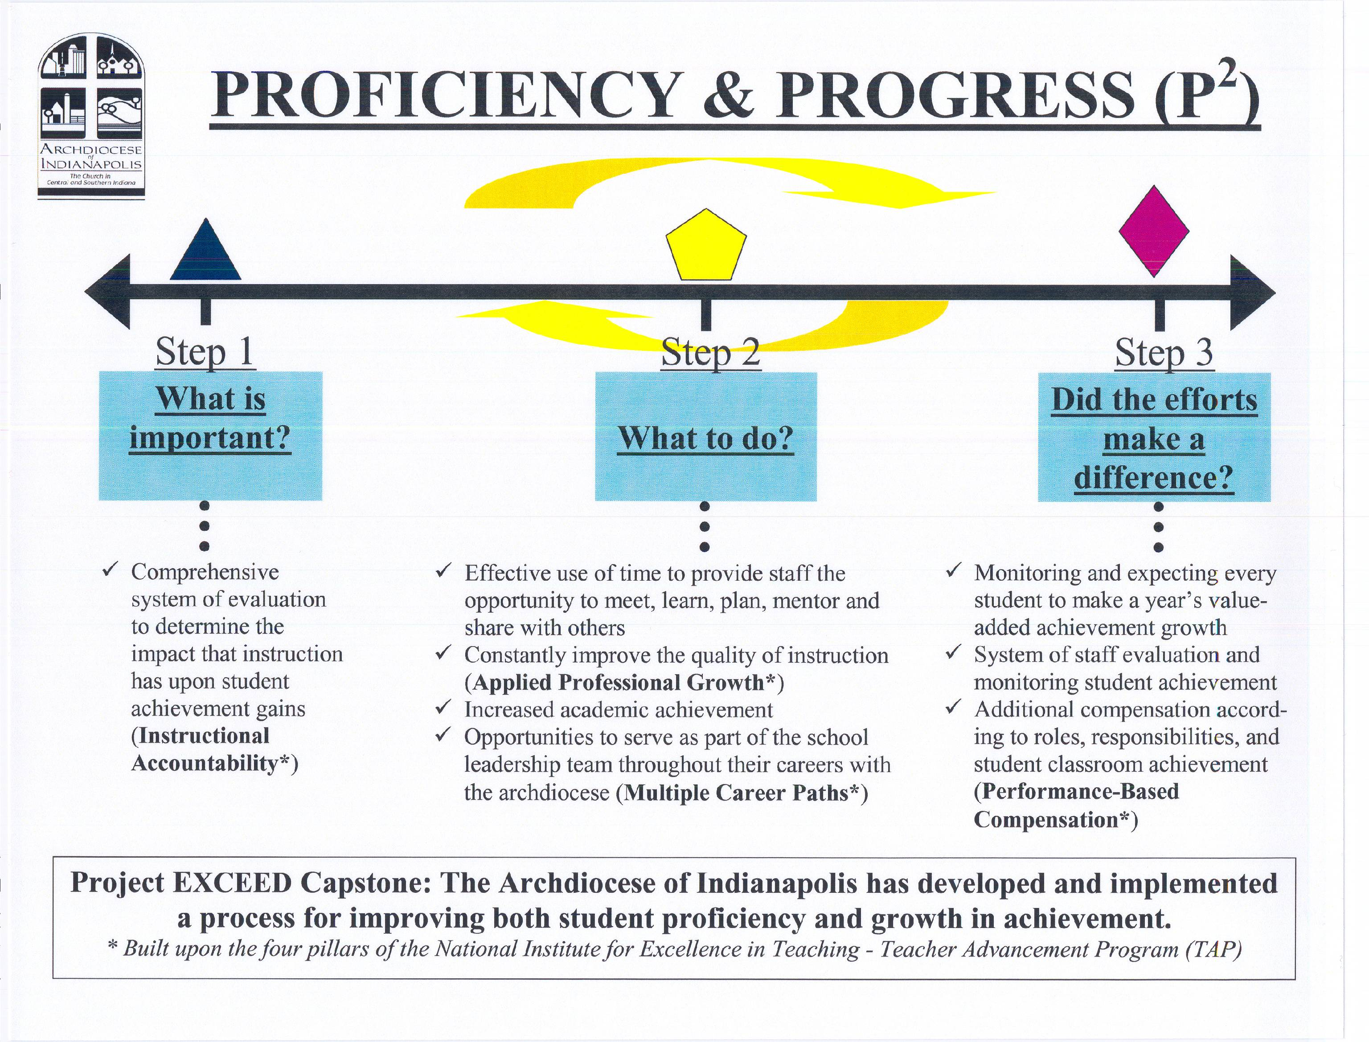

Project Exceed has created a significantly stronger school system for the Archdiocese of Indianapolis that provides:

- educators with the training and support needed to move students from average to exceptional;
- administrators with the tools to make decisions and implement school-level strategies to meet the needs of their students; and,
- students with the opportunity to become life-long learners, striving for proficiency and growth throughout their academic career.

Good is no longer enough; great must be achieved. Project Exceed is the vehicle that can move the archdiocesan schools from good to great. The results so far are measurable, powerful and indisputable. Now momentum must continue and grow beyond the initial implementation phase. We seek to leverage the best practices we have learned throughout the archdiocese and with other schools throughout the country. The next few months will be critical if the archdiocese is going to expand these efforts to the next level. If the goal is only to maintain what has been started, the goal can be achieved. But, if the goal is to expand these efforts and create sustainable systems across the archdiocese and into other schools, additional support will be required from Catholic, corporate and foundation communities to build upon the achievements of Project Exceed.

Capstone of Project Exceed

The Archdiocese of Indianapolis has had an unprecedented opportunity over the last six years to create and implement a program to improve student achievement. This was made possible by a grant from Lilly Endowment Inc. ($10 million) and other corporate contributions (+$6 million). Through more than 50 projects and activities, we have transformed how we measure, report, and expect our schools to demonstrate that they have made a difference for every individual student. As we attempt to define the crowning achievement of these activities and move forward, we do so with the following capstone for the Project.

The Archdiocese of Indianapolis has
developed and implemented a process for improving
both student proficiency and growth in achievement

As we move on, our task is to combine these findings and accomplishments into a comprehensive effort that can be both sustained and replicated. This will only be successful if there are a strong system of beliefs, foundation for expectations, and identification of areas that matter most.

System of Beliefs:
- Each individual has value and worth based upon our Catholic values and our Catholic Schools are expected to make a difference for each individual;
- To do this, schools must have highly qualified staff and be accountable by demonstrating this difference;
- Resources are limited and we need to guarantee that our decisions concerning their allocations are made in a timely and responsive manner.

Foundation for Expectations:
- Standards – defined expectations of proficiency;
- Assessment – monitoring proficiency and progress;
- Accountability – the allocation of resources to those making progress.

Identification of Areas:
- Information System – to monitor progress at the individual level.
- School Improvement/Accreditation – system for monitoring schools.
- Professional Development – coordinating activities across the archdiocese designed to improve staff effectiveness.
- Disadvantaged Populations – differentiating so that we include those that are usually not included.

Finally, our goal is to replicate and sustain our efforts across the archdiocese and into other school systems. To accomplish this, support will be required from Catholic, corporate and foundation communities to build upon the achievements of Project Exceed*.

The full Project Exceed report is available from Dr. Ron Costello at rcostello@archindy.org.

